***PROBLEM STATEMENT:***

***The problem is to develop a fake news detection model using a Kaggle dataset. The goal is to distinguish between genuine and fake news articles based on their titles and text. This project involves using natural language processing (NLP) techniques to preprocess the text data, building a machine learning model for classification, and evaluating the model's performance.***

***WHAT I UNDERSTAND:***

***Creating a fake news detection model is a valuable project. Here’s a high level outline of the steps you can follow:***

***1)*** ***1. *Data Collection:* Download the Kaggle dataset containing both genuine and fake news articles in text format. Ensure you have the necessary permissions to use the data.***

***2. *Data Preprocessing:* Perform various NLP preprocessing steps on the text data, including:***

***- Tokenization: Split text into words or tokens.***

***- Stopword Removal: Remove common words like "the," "and," etc.***

***- Lowercasing: Convert all text to lowercase.***

***- Lemmatization or Stemming: Reduce words to their base form.***

***- Removing Special Characters: Get rid of punctuation and symbols.***

***3. *Feature Extraction:* Convert text data into numerical features suitable for machine learning models. Common methods include TF-IDF (Term Frequency-Inverse Document Frequency) or word embeddings like Word2Vec or GloVe.***

***4. *Splitting Data:* Divide the dataset into training, validation, and test sets to train and evaluate your model effectively.***

***5. *Model Selection:* Choose an appropriate machine learning algorithm for classification, such as Logistic Regression, Random Forest, or a deep learning model like a Convolutional Neural Network (CNN) or Recurrent Neural Network (RNN).***

***6. *Model Training:* Train the selected model using the preprocessed text data from the training set.***

***7. *Model Evaluation:* Evaluate your model's performance using metrics like accuracy, precision, recall, F1-score, and confusion matrix on the validation set. Adjust hyperparameters as needed.***

***8. *Fine-Tuning:* Experiment with different model architectures, hyperparameters, and feature extraction methods to improve performance.***

***9. *Testing:* Assess the model's performance on the test set to ensure it generalizes well to unseen data.***

***10. *Deployment:* If desired, deploy the model to a web application or platform for real-time fake news detection.***

***11. *Documentation:* Create detailed documentation describing your approach, data preprocessing steps, model architecture, and how to use your fake news detection model.***

***12. *Ethical Considerations:* Ensure that your model and project adhere to ethical guidelines, including privacy and bias mitigation.***

***Regarding your mention of Word documents, it's a good practice to maintain documentation in various formats, including Word documents or PDFs, to keep track of your project's progress and findings.***

***Remember that the success of your fake news detection model largely depends on the quality and quantity of your data, the chosen NLP techniques, and the model's architecture. Continuous evaluation and improvement are essential for the effectiveness of such models.***

***SOURCE CODE:***

***import pandas as pd***

***from nltk.corpus import stopwords***

***from nltk.tokenize import word_tokenize***

***from nltk.stem import WordNetLemmatizer***

***# Load the dataset***

***data = pd.read_csv('kaggle_dataset.csv')***

***# Preprocess the text***

***stop_words = set(stopwords.words('english'))***

***lemmatizer = WordNetLemmatizer()***

***def preprocess_text(text):***

***words = word_tokenize(text)***

***words = [word.lower() for word in words if word.isalpha()]***

***words = [word for word in words if word not in stop_words]***

***words = [lemmatizer.lemmatize(word) for word in words]***

***return ' '.join(words)***

***data['text'] = data['text'].apply(preprocess_text)***

***python***

***from sklearn.feature_extraction.text import TfidfVectorizer***

***tfidf_vectorizer = TfidfVectorizer(max_features=5000)***

***X = tfidf_vectorizer.fit_transform(data['text'])***

***python***

***from sklearn.model_selection import train_test_split***

***X_train, X_test, y_train, y_test = train_test_split(X, data['label'], test_size=0.2, random_state=42)***

***python***

***from sklearn.ensemble import RandomForestClassifier***

***classifier = RandomForestClassifier(n_estimators=100, random_state=42)***

***classifier.fit(X_train, y_train)***

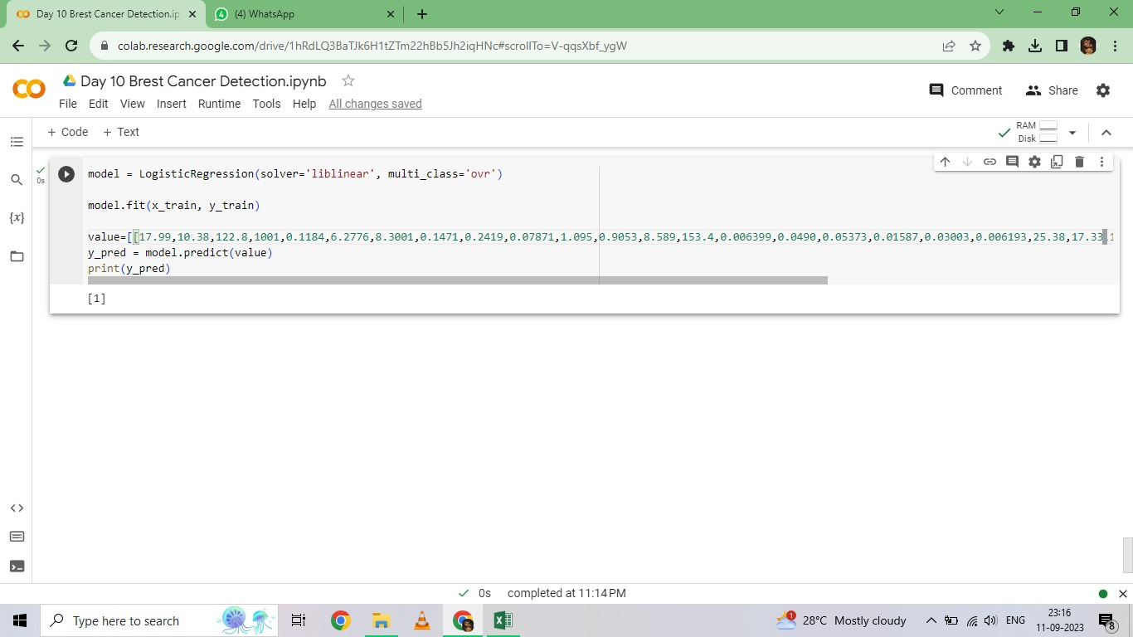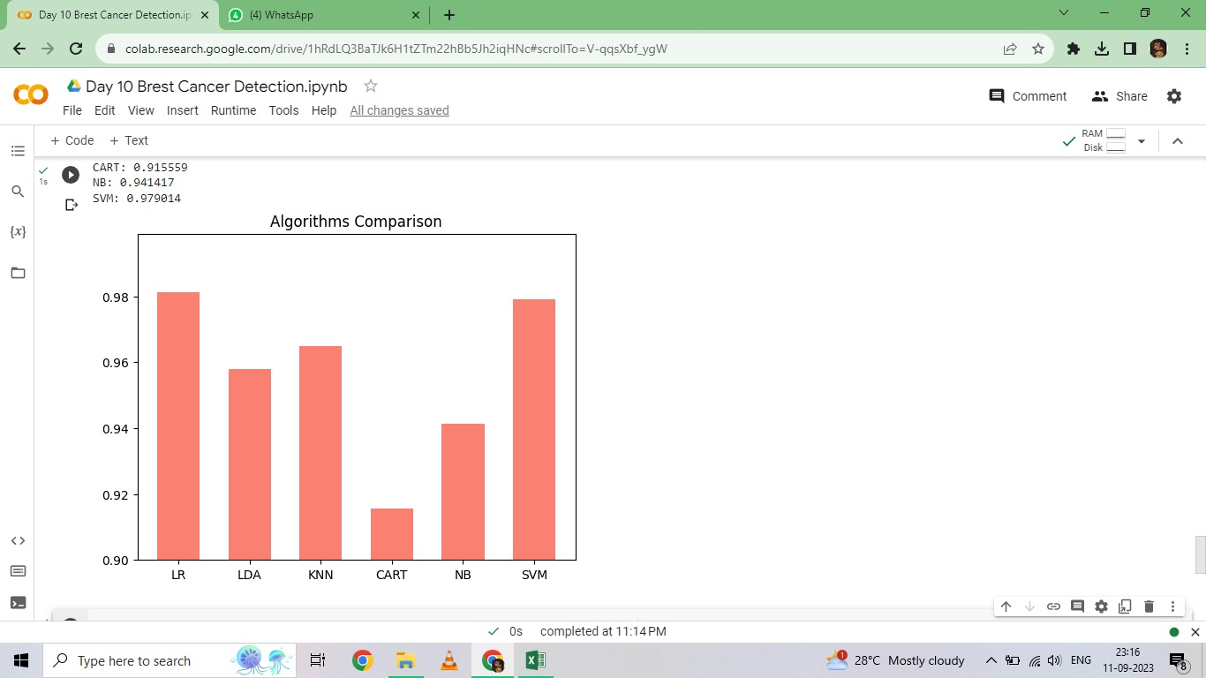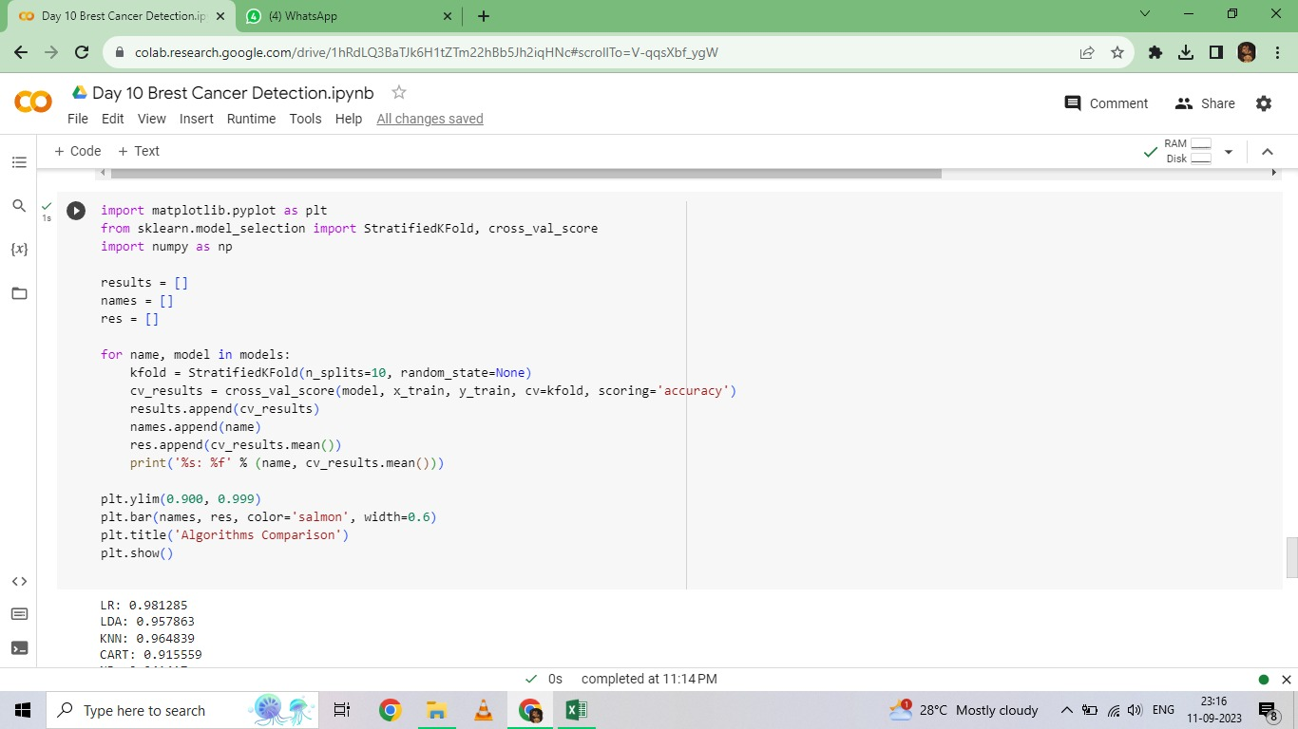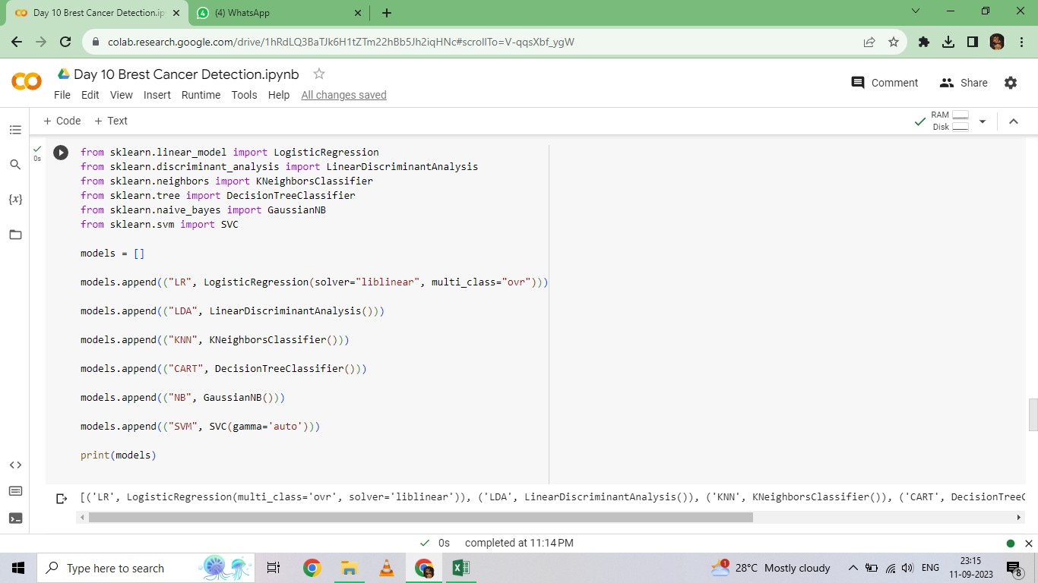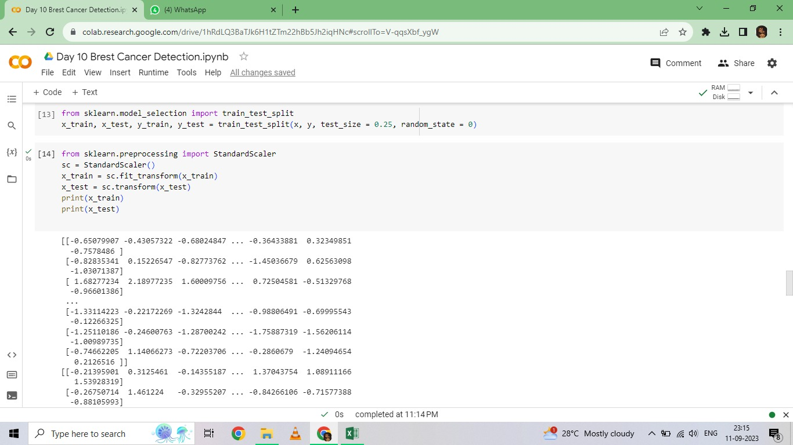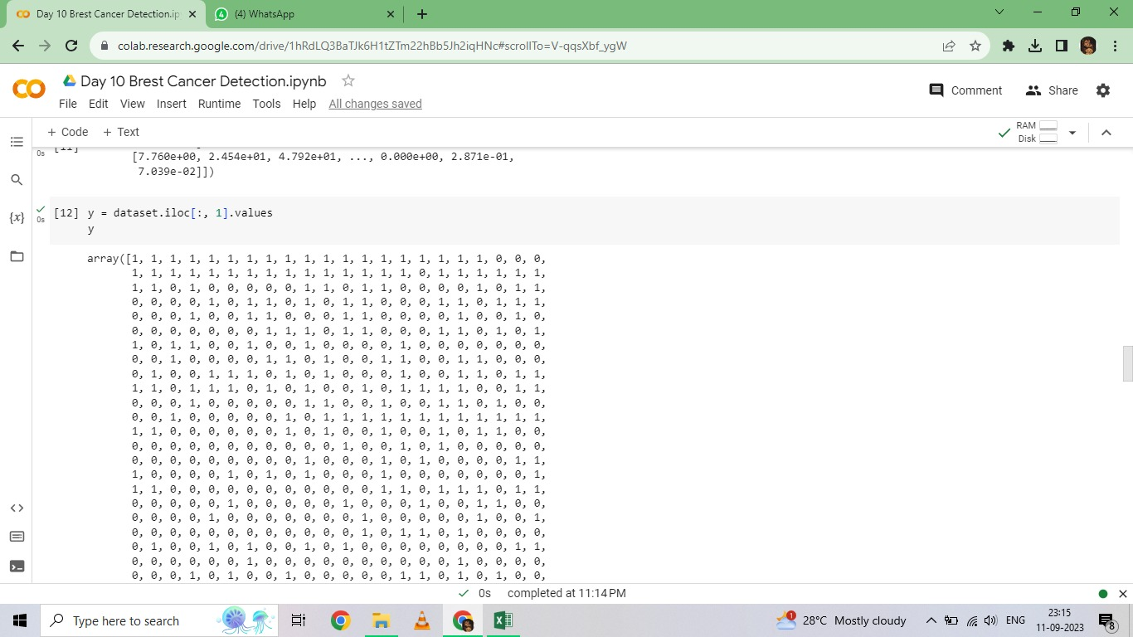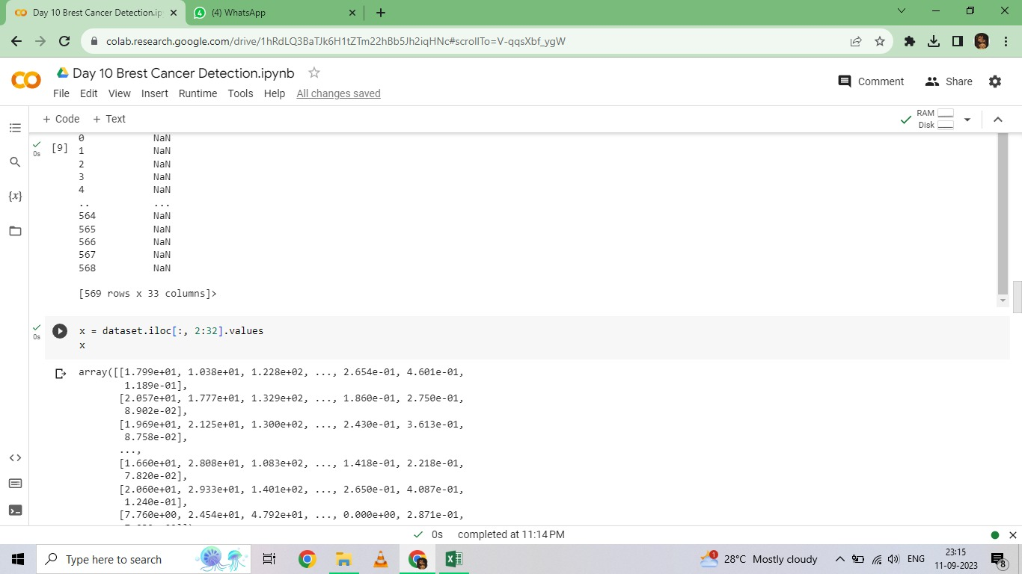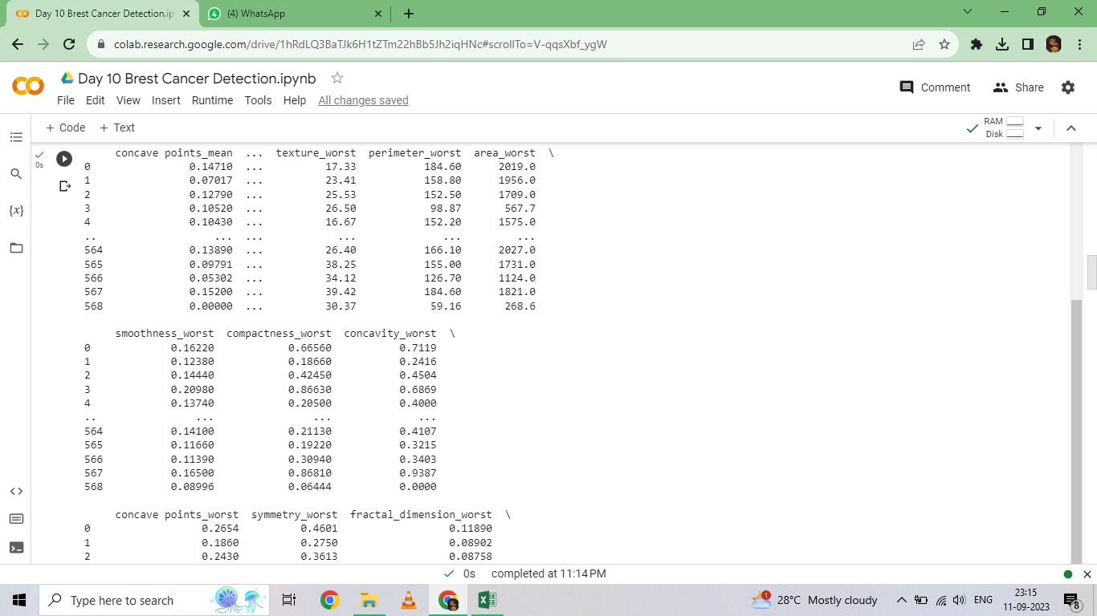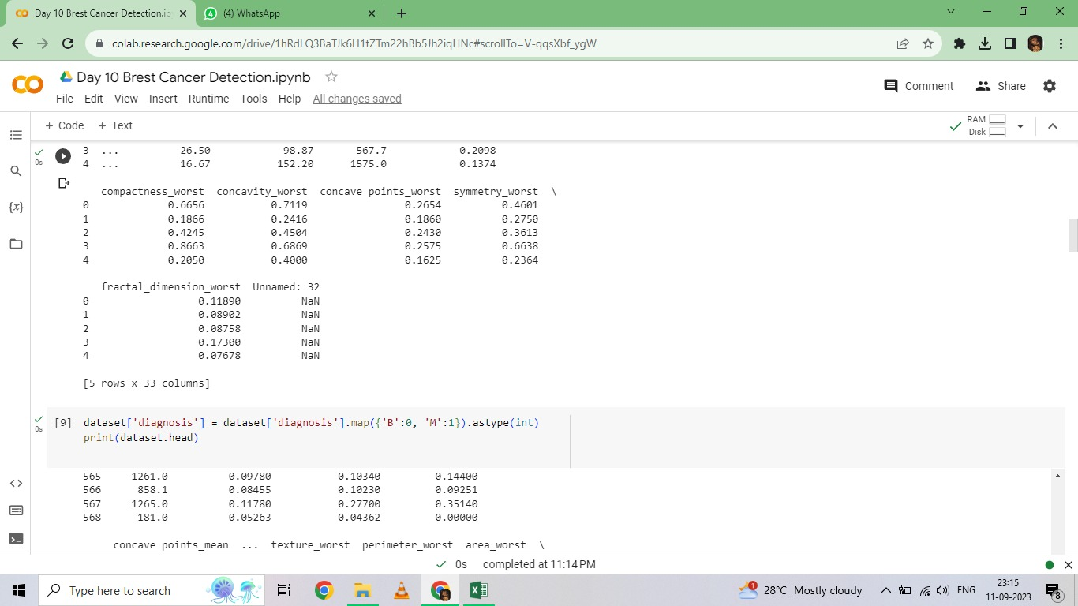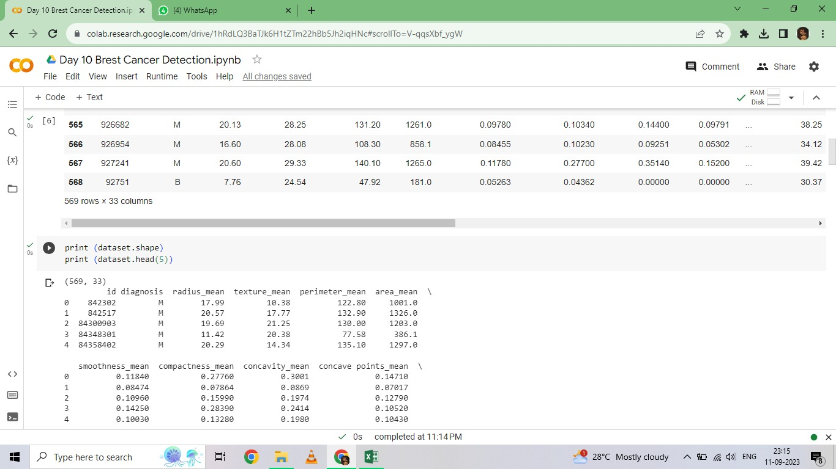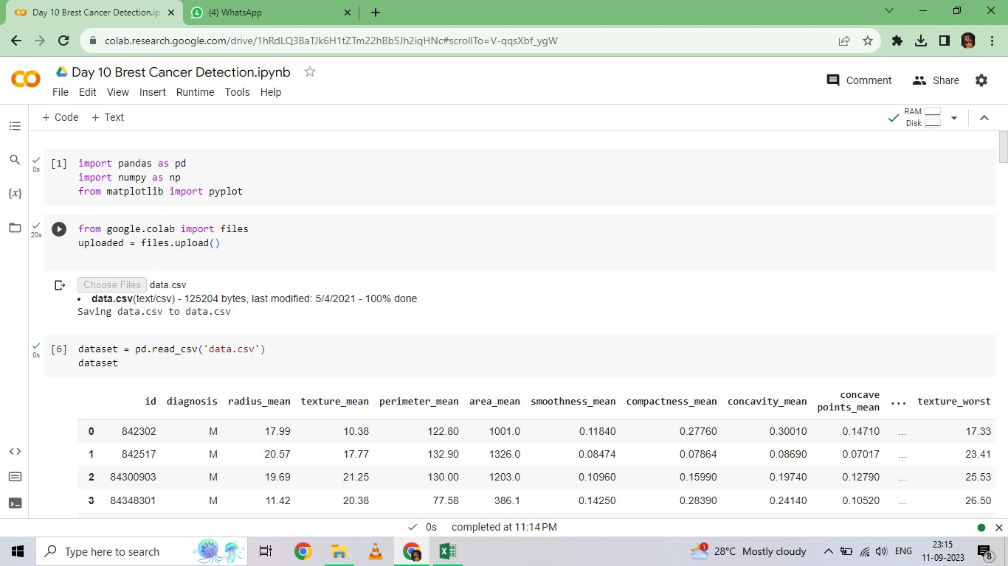

***NAME OF THE STUDENT: G.HEMALATHA***

***DEPARTMENT:BE-ECE/3rd YEAR***

***COLLEGE:M.P.NACHIMUTHU M.JAGANATHAN ENGINEERING***